**What is GitHub?**

GitHub is a code hosting platform for version control and collaboration. It lets you and others work together on projects from anywhere.

This tutorial teaches you GitHub essentials like repositories, branches, commits, and Pull Requests. You’ll create your own Hello World repository and learn GitHub’s Pull Request workflow, a popular way to create and review code.

**What is the difference between Git and Github?**

Git is the distributed version control system. Git is responsible for keeping track of changes to content (usually source code files), and it provides mechanisms for sharing that content with others. GitHub is a company that provides Git repository hosting.

**What is a repository on Github?**

Both Git and GitHub refer to this as a repository, or “repo” for short, a digital directory or storage space where you can access your project, its files, and all the versions of its files that Git saves.

VACTEST is the repository

<https://github.com/anshu713/VACTEST>

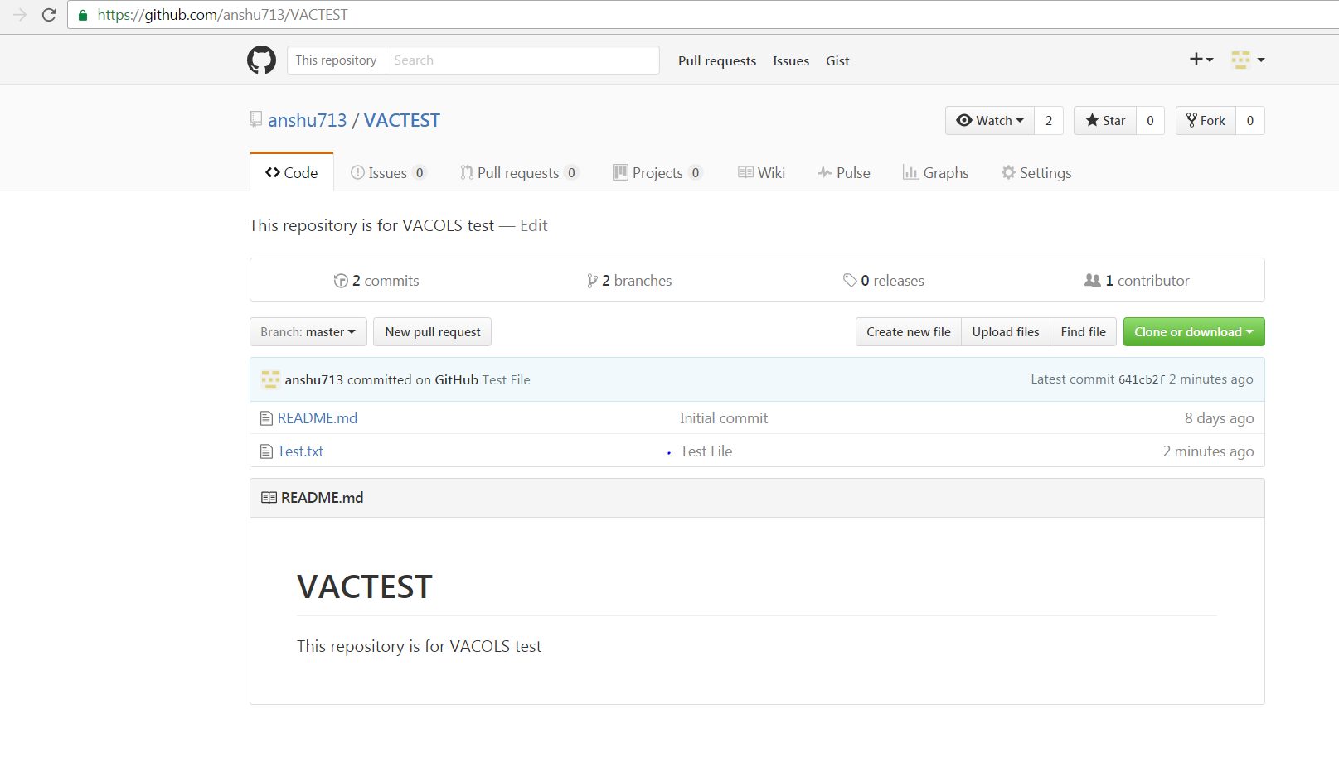

**Create/Upload and Commit files:**

On GitHub, saved changes are called commits. Each commit has an associated commit message, which is a description explaining why a particular change was made. Commit messages capture the history of your changes, so other contributors can understand what you’ve done and why.

Click below for new file or Upload files

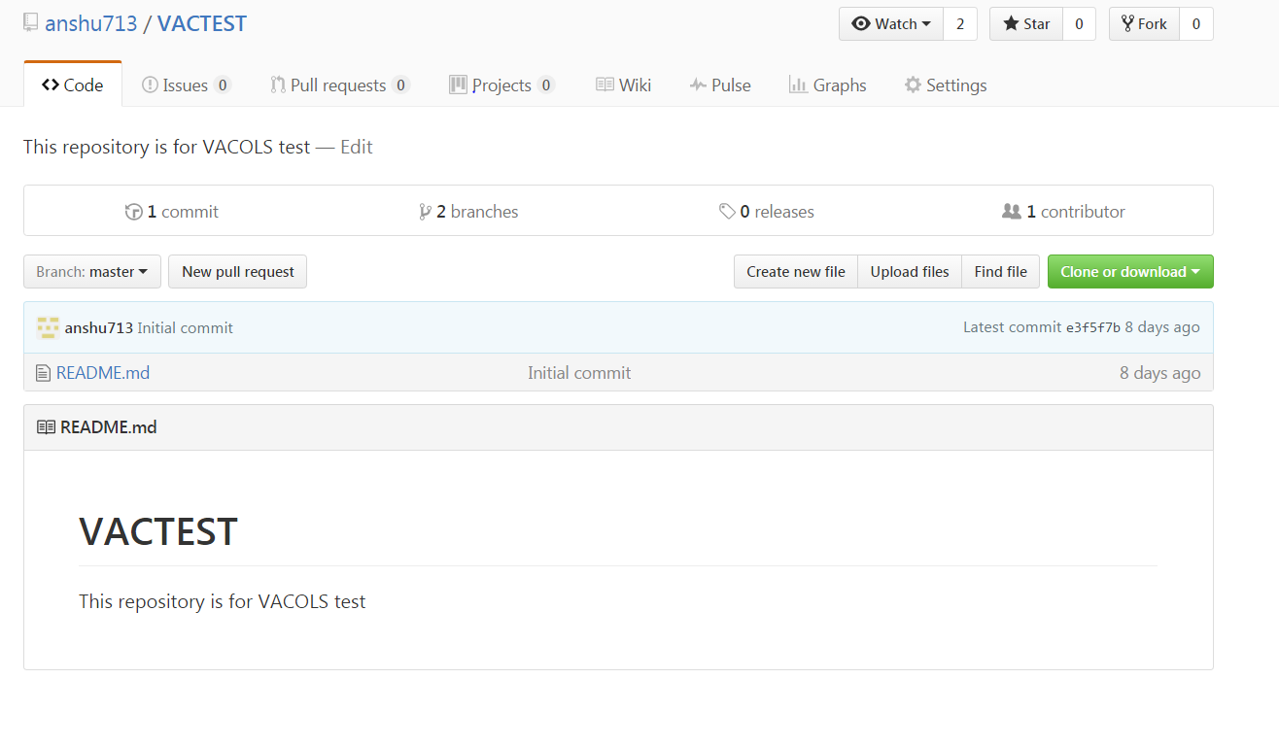

The below window will open. Drag or Choose files

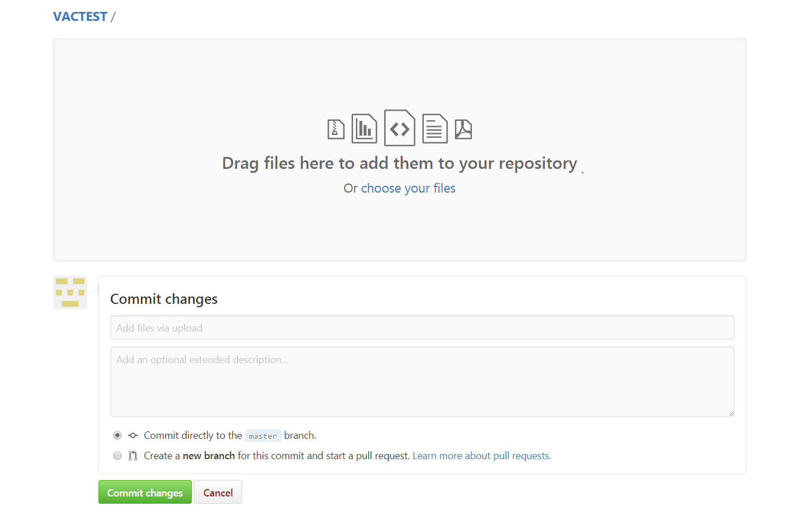

Write the comments and click commit changes

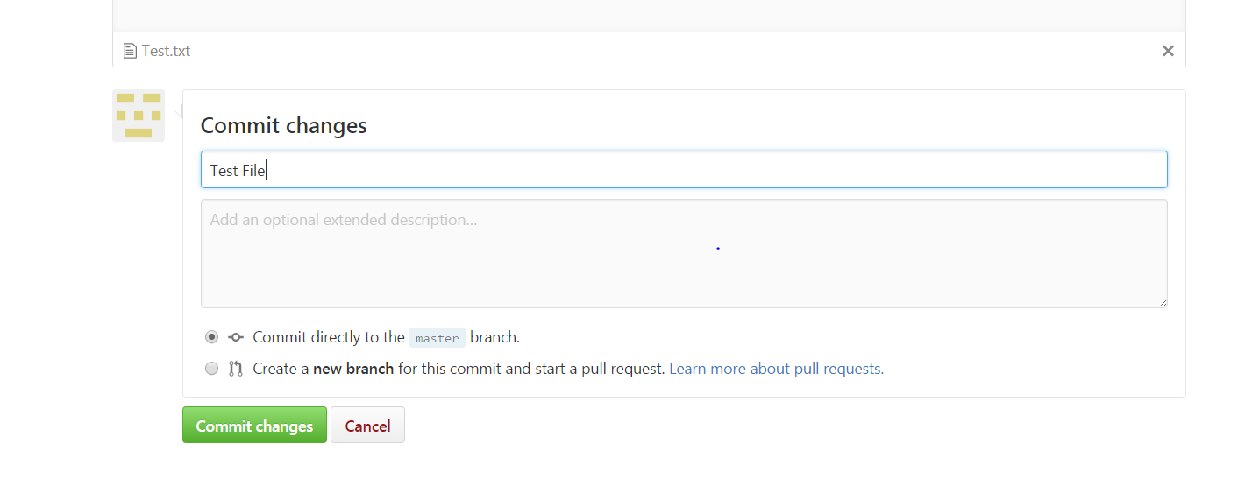

Now you see the file test.txt which we uploaded and committed in the below screen

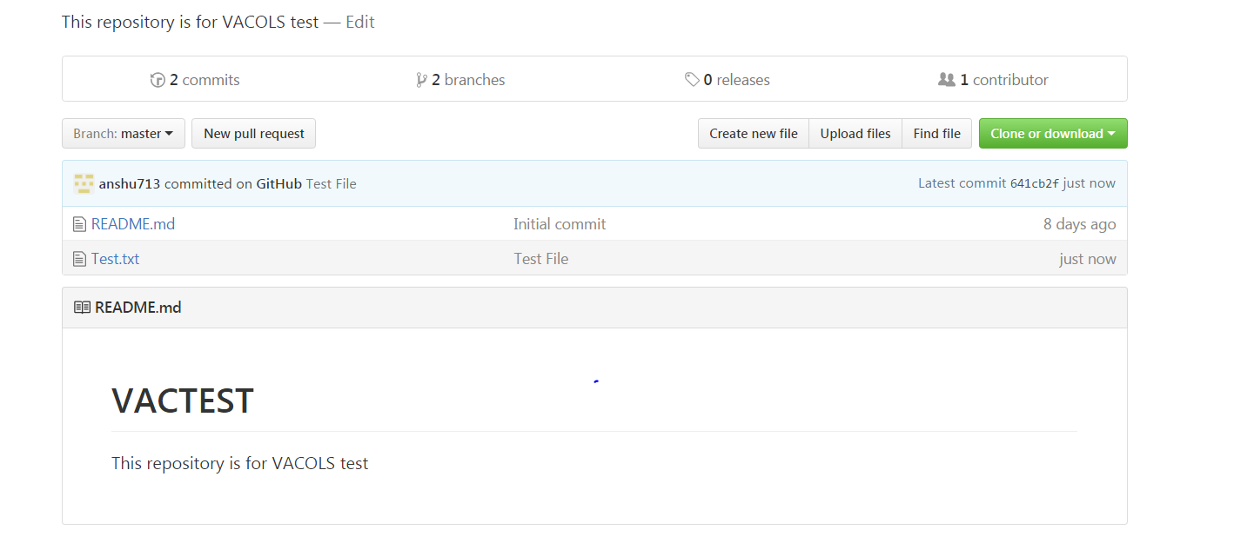

**Folder Structure:**

PB Code or Rel Name

Ruby On Rails

Requirements

Documentation

Images

Scripts

VACOLS Documentation

**To create a new branch**

Click the drop down at the top of the file list that says branch: master.

Type a branch name, readme-edits, into the new branch text box.

Select the blue Create branch box or hit “Enter” on your keyboard.

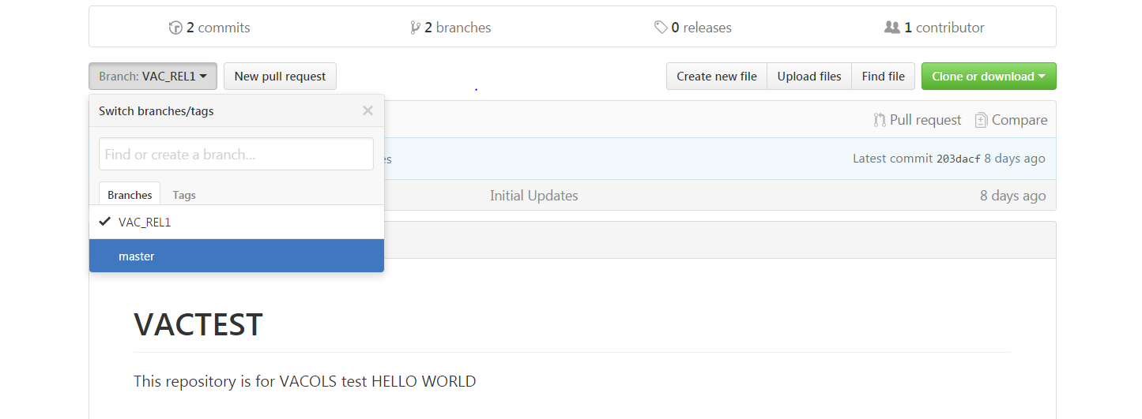

**How do you download from Github?**

Go to the file you want to download.

Click it to view the contents within the GitHub UI.

In the top right, right click the Raw button.

Save as...

**What is a git pull request?**

Pull requests let you tell others about changes you've pushed to a GitHub repository. Once a pull request is sent, interested parties can review the set of changes, discuss potential modifications, and even push follow-up commits if necessary.